Document Design (Audiobook JSON)

- Audiobook Structure:-

db.audiobooks.insertOne({
"title": "Rich Dad Poor Dad",
"narrator": "Robert Kiyosaki",
"duration_minutes": 360,
"tags": ["finance", "business", "self-help"]
})
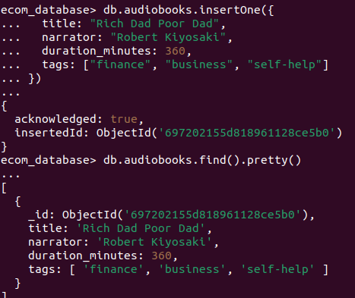

Explanation
- This document stores audiobook details in a structured format.
- MongoDB allows flexible and schema-less JSON documents, making it easy to store media-related information.

Embedding vs Referencing Reviews

- Audiobook Document With Embedded Reviews:-
Query: db.audiobooks.updateOne(
{ title: "Rich Dad Poor Dad" },
{
$set: {
reviews: [
{
user: "Amit",
rating: 5,
comment: "Very inspiring!"
},
{
user: "Neha",
rating: 4,
comment: "Good financial lessons"
}]}})

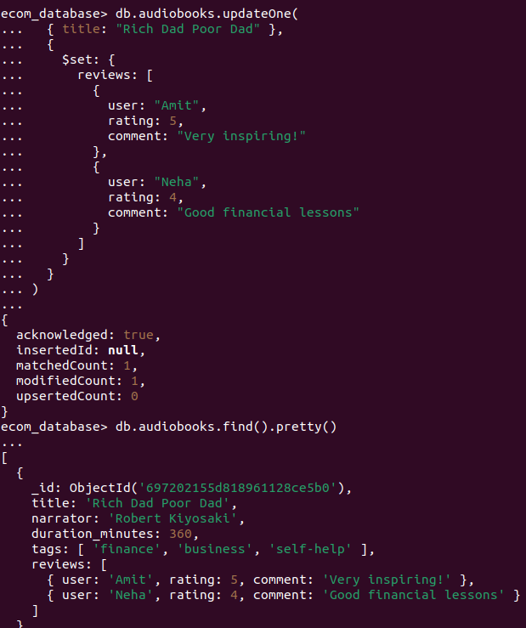

Explanation
Embedding stores reviews inside the audiobook document, which allows:
- Faster data retrieval
- Fewer database queries
- Better performance in read-heavy applications

